(Approx. 538 words)

Shotwell
By Cal Esneault, President, Cajun Clickers Computer Club, LA and leader of many Open Source Workshops & SIGs
June 2012 issue, Cajun Clickers Computer News
http://cccclinuxsig.pbwiki.com
www.clickers.org
ccnewsletter (at) cox.net

Digital cameras allow us to take as many pictures as we want without the cost of wasted film from bad shots. One result, however, is that we generate lots of image files that can be difficult to organize. Simple photo management software is available to help with organization and also to conduct basic editing of the original photograph. Picasa (from Google) has been a popular cross-platform program for this purpose, but Google recently announced it will not provide future updates for Linux users. DigiKam is the recommended alternative for KDE users. For GNOME users, Shotwell is the popular choice (it is now the default Ubuntu photo manager, replacing F-Spot).

Shotwell can import photos and videos directly from your camera, or you can import images from existing files (it supports JPG, PNG, TIFF, and BMP file types). It will automatically arrange photos by date. In addition, you can add one or more “tags” to the photo for additional grouping. In the screenshot below, you see pictures tagged with “New York.” Some pictures also have additional text specifying specific location. On the
task pane on the left-hand side, you can click on “New York” to see all from that state, or click on a particular location to see those just from that locale. Clicking on the date identifiers will display photos from that time period regardless of location. Other common tags to use would be to append text for a person’s name or for a special event (birthday, vacation, etc.). You can add, delete, or edit the tags at any time.

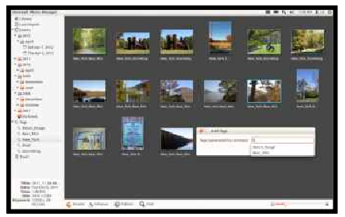
Shotwell has editing features to let you rotate, crop, and eliminate red-eye defects. It also has a very simple but effective exposure and color balance tool with live histogram response (see below). The “enhance” tool automatically guesses appropriate intensity levels and is a powerful and quick way to rapidly get your photos looking great.
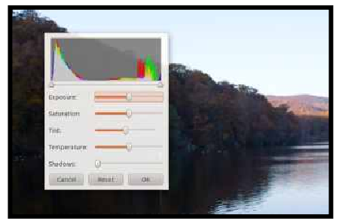
Shotwell has the ability to publish photos and videos to Facebook, Flickr, and Picasa. Currently, Shotwell has very limited capabilities for RAW images. They will be loaded but changed into JPG structure for editing.

As with any album software (either music or photographs), it is best to pick the one you like and stick with that choice. The key point is that the tags and other labels are tracked in an internal database. If you move the files manually, you can break the link to the database file. Shotwell does allow you drag and drop photos within its structure. When importing images into the Shotwell system, the files are copied into a designated file folder, thus keeping your original files. One approach is to use the program to load your “best” images so that you can use it to review them quickly and share with others.

The thrust of Shotwell is to be an image manager. For more complex editing tasks, a bit-map editing program such as The GIMP is recommended for refining the picture before importing into Shotwell. The program is available for Linux via most package mangers. For more information, see yorba.org/shotwell.

